Jeremiah's

Kansas City Style BBQ

Barrel Oak Winery 3623 Grove Lane, Delaplane Virginia 20144
November 19TH, 2021

SURF & TURF
Smoked Prime Rib-6 oz Cut with Au Jus
6 Large Steamed Shrimp- Unpeeled with
Cocktail Sauce & Lemon
Fresh Cut Steak Fries OR Rice Pilaf
Seasoedn Green Beans or Buttered Corn
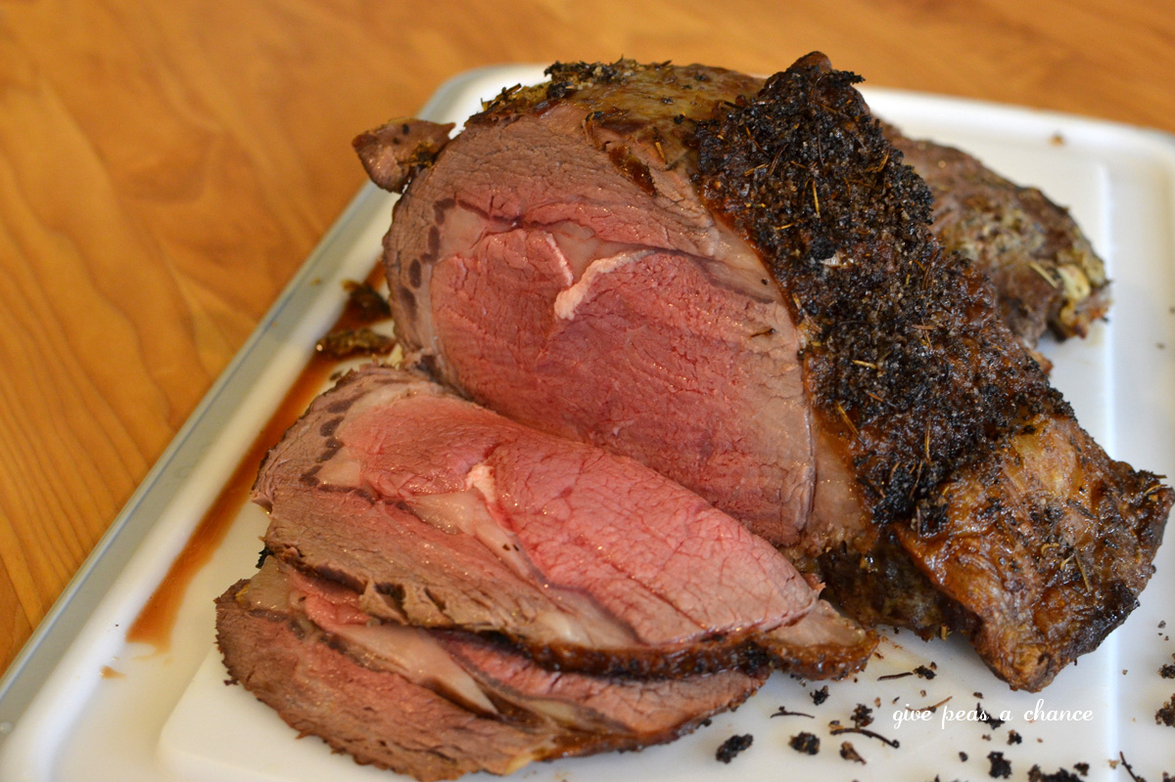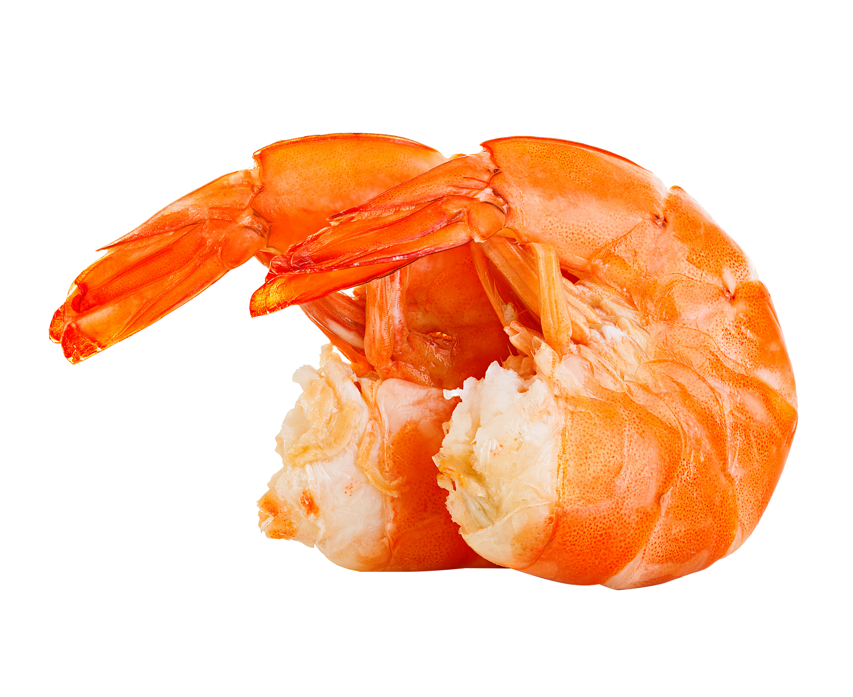
This Photo by Unknown Author is licensed under CC BY-NC-ND
This Photo by Unknown Author is licensed under CC BY-NC
November19th, 2021-MEAL SERVING TIME 1:OOPM TO 6:00PM
$35.00 Guest
BAR BQ MENU AVAILABLE ALSO 12NOON TO 7:00PM

“You’ve tried good, now try GREAT!”

